Movies Analytics using Azure Data Factory
Problem Statement
Use Azure Data Factory's visual authoring experience to create a pipeline that copies movie data stored to Azure Data Lake Storage Gen2 and then executes a Mapping Data Flow to transform and write the data to a Azure SQL Database.

Ingesting data into Azure Data Lake Storage Gen2
● Create a new azure data lake container with name as azure-project
● Upload the data into this container

Create an ETL pipeline from data lake to sql db with following transformations.
● List down all unique genres and their number of occurrences for all those movies where rating is greater than 5.
● Write down these genres and count combinations into 2 column tables in azure sql db.
○ Schema = Test
○ Table Name = generes
Submissions
You are supposed to submit the screenshots of all the activities like
● Creation of data lake container
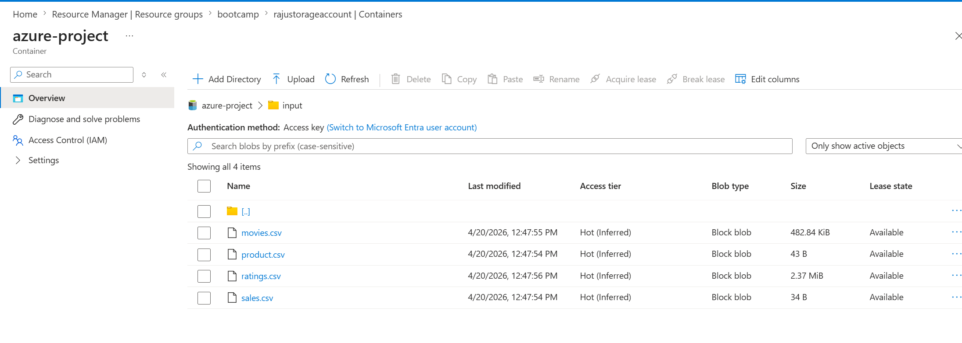

● Creation of 2 linked services

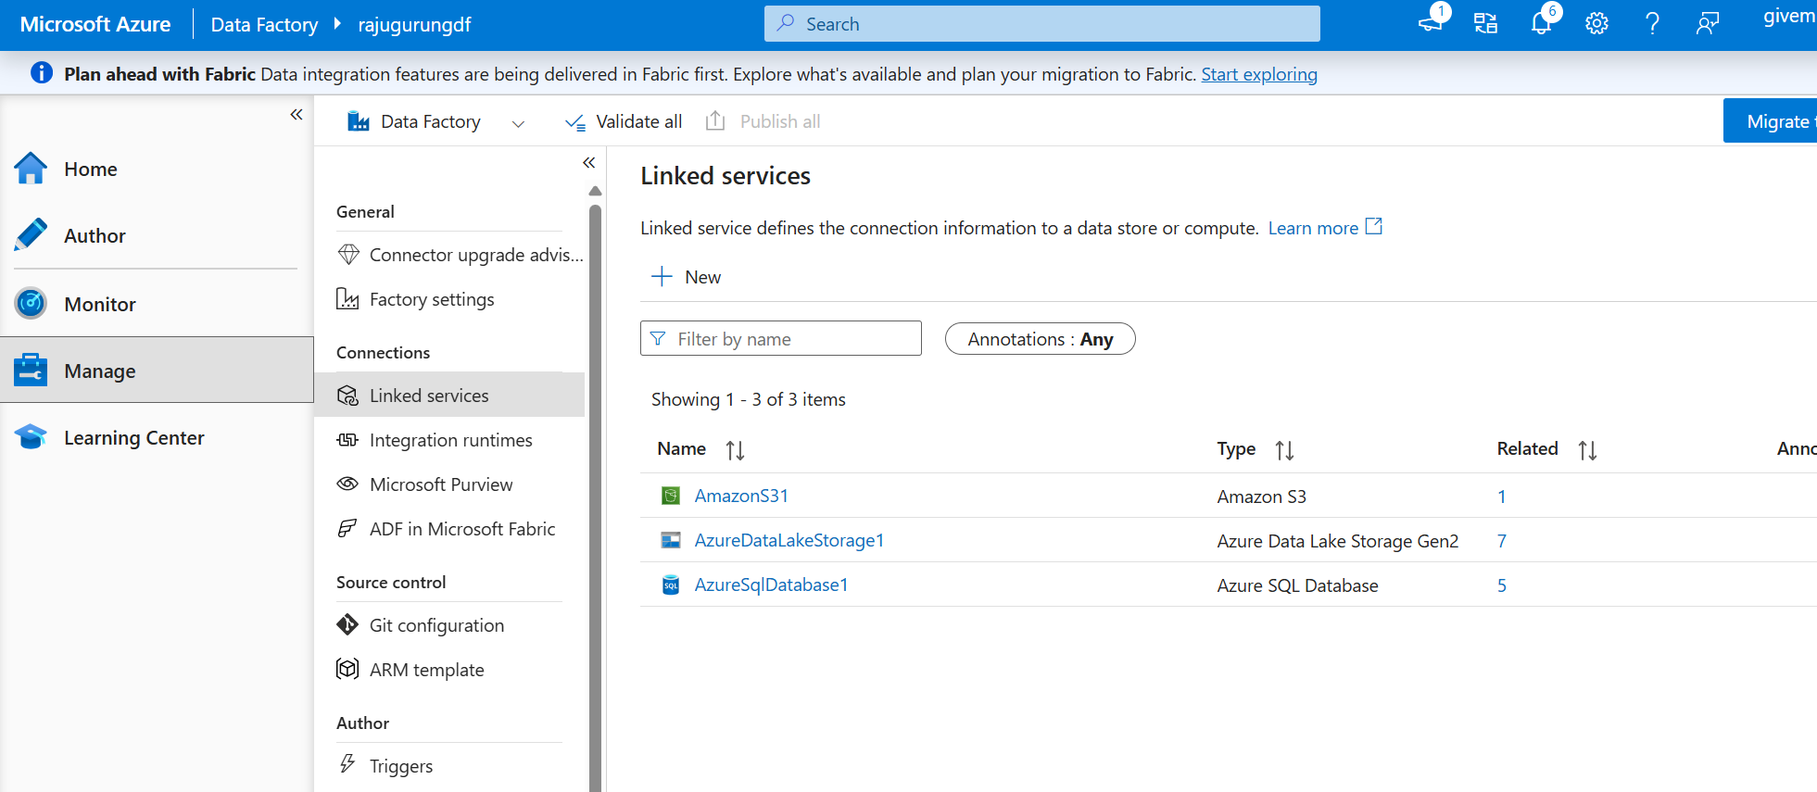

● Creation of datasets
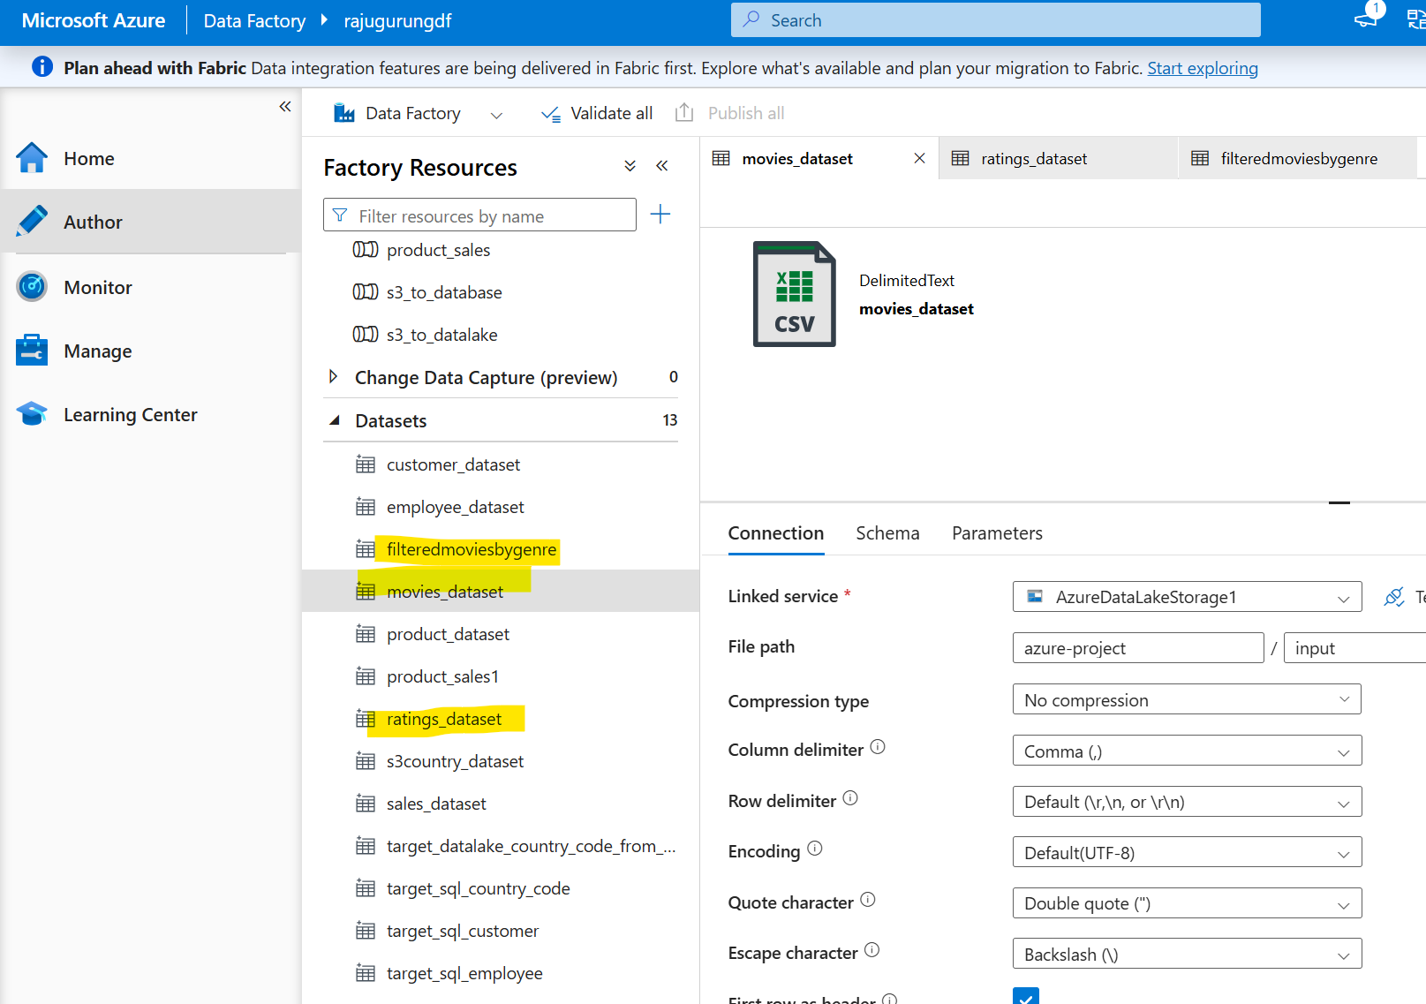
● Creation of dataflow

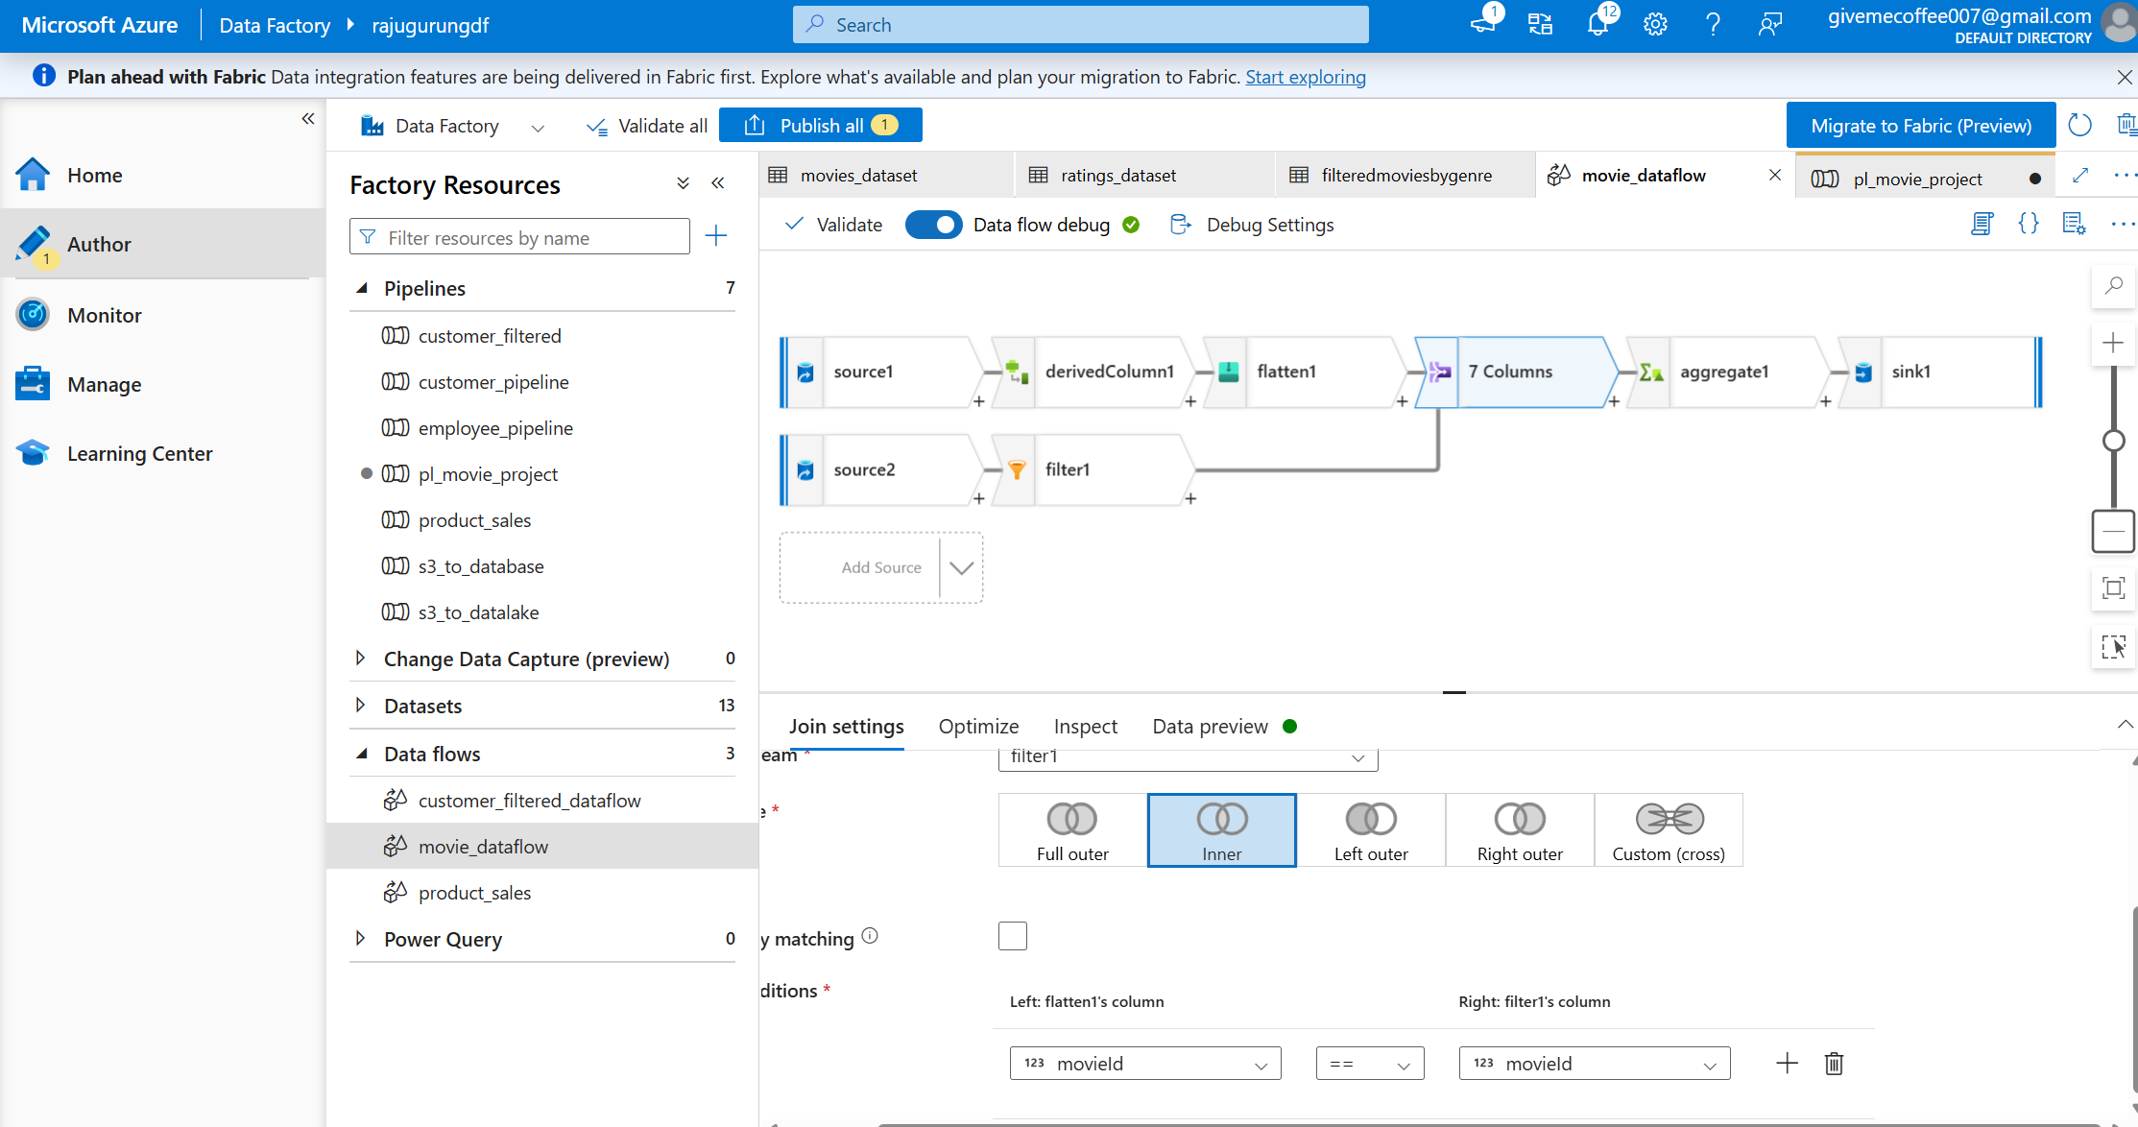

● Creation of pipeline

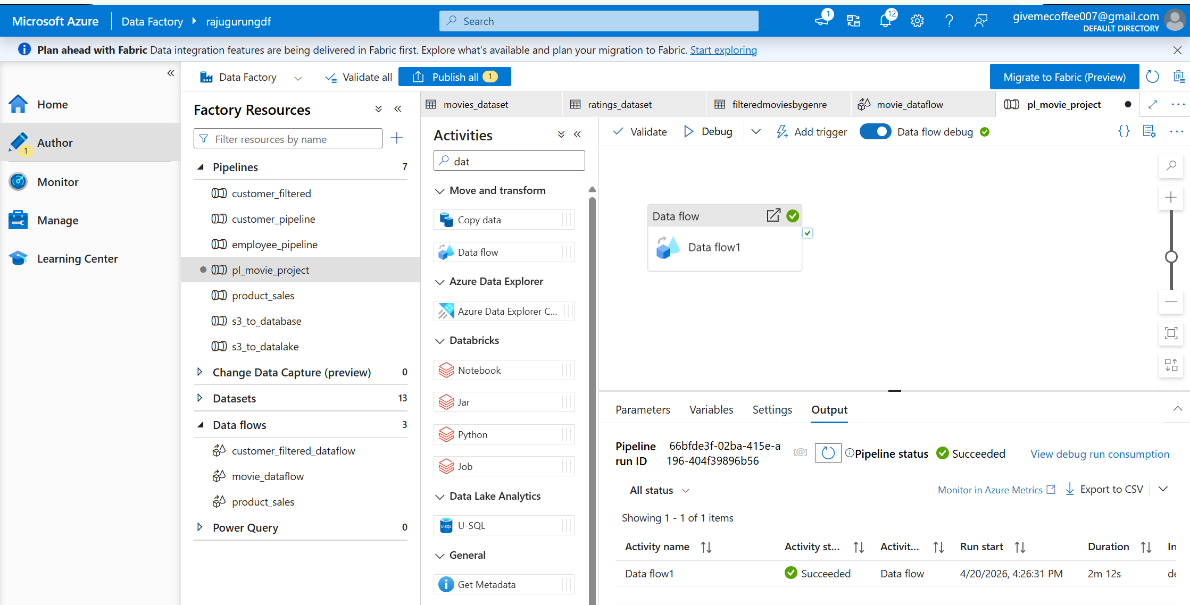

● Preview output of final sql db table
